
For Office Use Only:
In town: $_____
Outside City Limits:
$_____
For Office Use Only:
P & R: ___________
NCR: ___________
Other: __________

Today’s Date:______________
Passenger’s Last Name: _________________________ First Name: ________________________ Middle Initial:______
Street Address: _____________________________________ City: ____________ State: _______ Zip: ________
Birthdate: ______________ Sex: M / F Home Phone #: _________________ Cell #:___________________

Ambulatory___ Wheelchair/Lift ___ Ethnicity: Caucasian/ Hispanic/ African American/ Native American/ Asian/Other

PT Passport is active from June 1, 20___ to August 31, 20___
Please use the calendars provided for all activities.
CALENDAR INSTRUCTIONS:
- Fill in child’s name and month at the top of the page. Make sure to fill in the calendar dates for each month.
- Fill in the activity for each day. If the activity is the same for the following day, write “same”.
- Include if the child is riding one way or round trip. You can put “RT” for the round trip abbreviation.
- Put the activity start and end times at the bottom of the page.
( EXAMPLE OF CALENDAR ON BACK )

Example:
1 |  |  | 2 |  |  | 3 |  |  | 4 |  |  | 5
Tennis and Swimming |  |  |  | “Same” |  |  | “Same” |  | Tennis only |  |  | No rides.
 | “RT”
*PLEASE PUT ACTIVITY START AND END TIMES HERE:
Swimming: 11:20am – 12:oopm Tennis: 9:30am – 11:00am

***IF YOU HAVE ANY QUESTIONS PLEASE DON’T HESTITATE TO CALL #605-353-0100

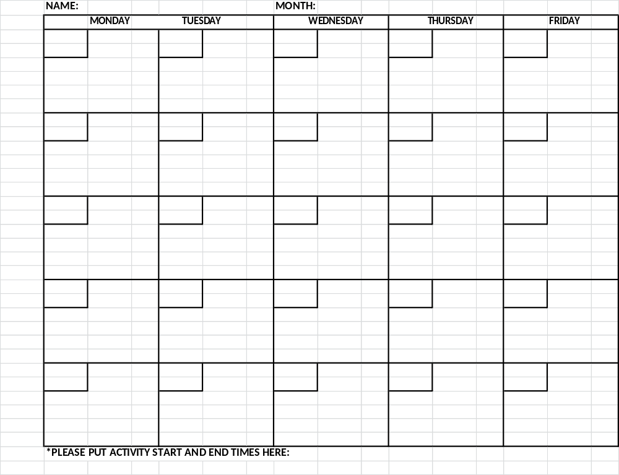
PARENT / LEGAL GUARDIAN INFORMATION

Name: _________________________________ Address: __________________________________________________
__________________________________________________

Home Phone #: __________________ Cell Phone #: _____________________ Email :__________________ _________

EMERGENCY CONTACT: Name:____________________________ Phone #:____________________________________ Relationship: ______________________

PASSENGER AND /OR LEGAL GUARDIAN PLEASE READ AND INITIAL THE FOLLOWING:

______ I UNDERSTAND that the PT Passport is only valid from June 1st to August 31st. This registration does not count as a school registration for the upcoming year.
______ I UNDERSTAND that People’s Transit has a NO REFUND POLICY .
______ I UNDERSTAND that any ride that is not cancelled will result in a no-show fare of $2.50.
______ I UNDERSTAND that I need to pre-schedule (By 4:30pm the day before).
______ I UNDERSTAND that any cancellations must be made by 4:30pm the day before.
______ I am responsible for updating my personal information as needed. This includes change of address or phone number. Failure to do so may result in a no show.
______ I UNDERSTAND that ANY misconduct on the bus will result in a warning and a parent or guardian will be notified. If the problem persists the rider will be suspended. The length of suspension will depend on the seriousness of the misconduct. BULLYING WILL NOT BE TOLERATED!
______ I UNDERSTAND that People’s Transit reserves the right to refuse service.
______ I UNDERSTAND that People’s Transit is committed to providing NON- discriminatory service & that I may call the office with any concerns.
______ I UNDERSTAND that as a parent/ guardian if I am not outside or in the doorway when People’s Transit drops my child off, the child will be taken to our office unless otherwise given permission to drop off unattended. While the child is at the office, we will continue to contact all contacts listed on the rider registration. If no one can be reached by the time our office closes, authorities will be notified.
______ I UNDERSTAND that if my child damages a bus, the Parent/ Guardian will be responsible for damages.
______ I UNDERSTAND that I must fill out a new rider registration every school year, as well as for any summer or after school programs.
The above information is true to the best of my knowledge.

___________________________________________________
Parent/ Guardian Signature Date

